GENERAL RULES FOR AUTHORS  Conference papers (2-3 pages in volume) should be sent in English before March 15th, 2014 to the e-mail address: agronomia@mail.ru.  Layout: MS Word; page А₄ (210 х 297 mm); margins: 20 mm – head, right and left, 25 mm – foot; line interval – 1,0; font - Times New Roman 12; indention – 1,0 cm; text margin aligned; automatic hyphenation.  The title of the paper follows after a line interval - centred, in bold type, capital letters. Initials and surname of the author(s) follow lower, centred. Title of the organization, address, postal code, country, and E-mail - one line below, centred. Key words must be placed below, in italics, no indent, not centered. The text follows after one line interval.  Paper must consist of the following parts: Introduction, Materials and Methods, Results and Discussion, References. Title of each part should be centred, in bold, small letters.  For additional information (e.g. how to design tables and figures) visit Rules for authors of Russian Journal of Plant Physiology (http://77.50.239.203/).  Accepted for publication papers will not be edited.  paper Fee  Proceedings: paper fee is equal to EUR 4 (in Roubles) for each paper independent on quantity of authors. It is paid by foreign participants in cash at the time of registration.  Journal «Acta KSTU» - free. | Important dates  First Announcement 10.11.2013  Registration form and article  for Proceedings 15.03.2014  Second Announcement 01.04.2014  Confirmation of participation,  hotel reservation 10.05.2014  Conference Program 10.05.2014  Arrival of participants 19.05.2014  Departure of participants 24-25.05.2014  Conference and  School sessions 20-24.05.2014  Submission of articles for  «Acta KSTU» journal 15.06.2014  Publication of «Acta KSTU» 01.08.2014  ATTENTION!  Foreign participants to get an official invitation for a visa from Organizing Committee, have to send Registration form and article for Proceedings before February 1st, 2014. Apart from it, they have to fill in the Application Form (see attached file) and enclose a digital copy of passport’s first page. All documents in digital form must be sent to E-mail: agronomia@mail.ru before February 1st, 2014.  Arrangement Fee  Arrangement fee is equal to:  - for foreign participants – EUR 50,  - for young foreign scientists (younger than 30 years old) – EUR 25,  - for attendants– EUR 25.  Foreign participants pay the fee by cash (in Roubles) at the time of registration. |  | Ministry of Agriculture of the Russian Federation  Портрет  Russian Academy of Sciences  Federal Agency of Scientific Organizations  Federal Agency for Fisheries  Kaliningrad State Technical University  Timiryazev Institute of Plant Physiology RAS  Russian Society of Plant Physiologists  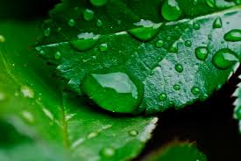  Annual meeting of Russian Society  of Plant Physiologists  International scientific conference  and School for young scientists  «PLANT PHYSIOLOGY  AS THEORETICAL BASIS  FOR INNOVATIVE AGRICULTURE AND PHYTOBIOTECHNOLOGIES»  First announcement  May, 19th-25th, 2014  Kaliningrad, Russia
Dear Colleagues!  We invite you to participate in the International scientific conference and School for young scientists «Plant Physiology as Theoretical Basis for Innovative Agriculture and Phytobiotechnologies». The conference will be held in Kaliningrad, Russia, from 19th till 25th of May, 2014 at the premises of Kaliningrad State Technical University. Information on this conference is published on the University Web-site: http://www.klgtu.ru/ (Наука → Конференции, семинары, симпозиумы → в КГТУ), also availible on http://ofr.su  Sessions  Section 1. Molecular-Physiological Basis of Plant  Growth, Development and Productivity:  - Formation of Plant Organs  - Plant Signaling System  - Regulation of Genome Expression  Section 2. Ecological Plant Physiology:  - Physiological-Biochemical Aspects of Plant Stress and Adaptation  - Biological Sustainability of Phytocenoses  - Plants under the Technogenic Environmental Pollution  Section 3. Agriculture and Phytobiotechnologies:  - Cell and Tissue Biotechnologies  - Transgenesis and Biosafety  - Biologically Active Compounds in Plant Growing and Biotechnology  - Innovative Technologies in Agriculture  presentations  and Papers  Plenary lectures (lecturers will be invited by organizing committee), oral sessions (10-25 min long) and posters are provided.  Proceedings will be published by the beginning of conference. A special issue of KSTU journal «Acta KSTU» will be published as a result of the conference. |  | 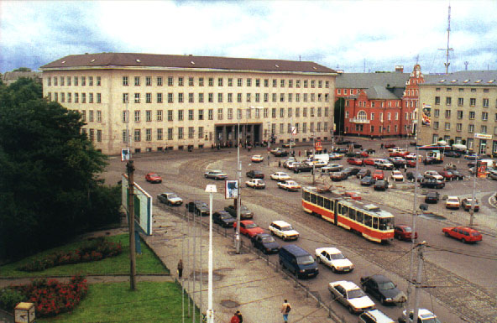  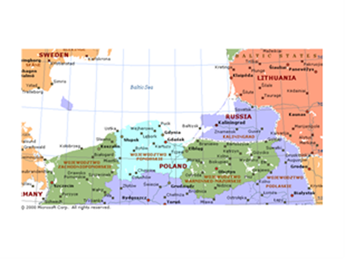  Kaliningrad is situated in the middle of Europe, on the eastern coast of the Baltic Sea. It is surrounded by Poland and Lithuania and has no boundaries with Russia. Its territory has very interesting and difficult history. You are invited to participate in the Conference, which will be held in Kaliningrad. Your Russian colleagues will do their best to make you feel welcomed and comfortable during your visit. We promise you interesting scientific and cultural program.  OFFICIAL LANGUAGES  Russian, English  coRresPONDENCE  Prof., Dr. Elena S. Ron’zhina, 236022 Russia,  Kaliningrad, Sovetskiy prospect, Kaliningrad State Technical University, Department of Agronomy,  E-mail: agronomia@mail.ru.  You are welcome! |  | registraTION form  For participation at the International scientific conference and school for young scientists "Plant Physiology as Theoretical Basis for Innovative Agriculture and Phytobiotechnologies" (Kaliningrad, May, 19th-25th, 2014)  Surname ________________________________  First name _________ Second name ___________  Organization ______________________________ _________________________________________  _________________________________________ _________________________________________  Position __________________________________  Degree (title)______________________________  Honor degree _____________________________  Country, postal code (zip), city _______________  Address __________________________________  _________________________________________  Phone (with code) __________________________  FAX (with code) ___________________________  E-mail___________________________________  Title of article for Proceedings ________________ _________________________________________  _________________________________________  _________________________________________  Session (number) __________________________  I intend (mark):  □ To make an oral presentation (10-25 min. long)  □ To make a poster  □ To publish an article in Proceedings  I am a young scientist (mark)  □ Yes  □ No  Arrival date ______________________________  Departure date ____________________________  Attendant(s)(number) _______________________  Booking of the hotel (mark):  □ Yes □ No Number of persons __________  Please, fill in this registration form for each participant separately and send it to the Organizing Committee to E-mail: agronomia@mail.ru

